# RANDOM WALK SIMULATOR

Simulated example

### Packages to download

1. ggplot2
2. gganimate
3. gtools
4. magick
5. gridExtra

### Calculate_Steps() function

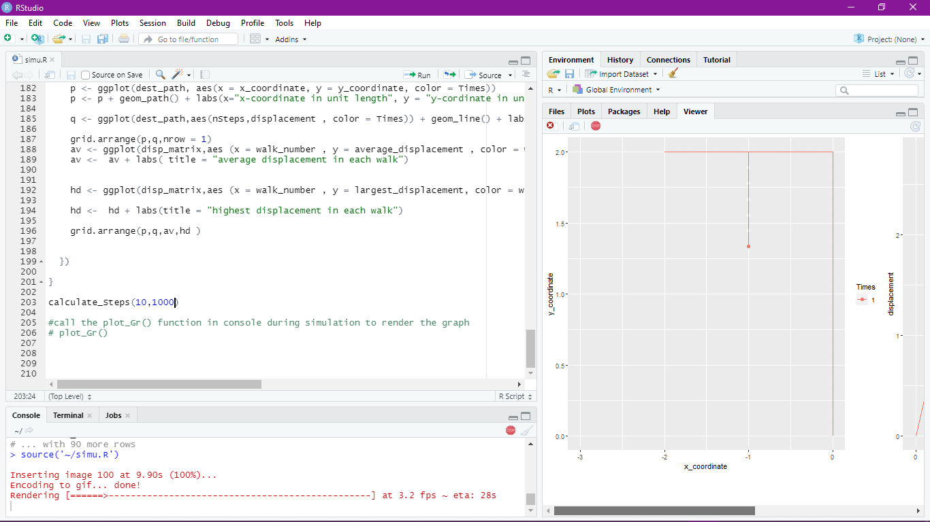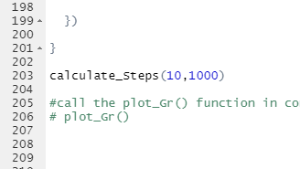

The **calculate_Steps(number of simulation, number of steps in each simulation)** take two arguments , first the **number of times to simulate the walk** and second **the number of Steps.**

#### The result of running the function is the gif shown below.



fig(1) fig(2)

10 simulations with 1000 walks The displacement of 10 simulations

each with displacement from

origin at each point

## 

## 

# plot_G() function call

To stop the simulation and plot the graph

## 

### 

### Calling the function plot_Gr in the console stops the simulation gif and

### prints the graphs like below

### 

### 

## THANK YOU!!

**Name : Sujan Bohora**

**Roll number : 89**

**ASCOL, 3rd Sem , Section B**